2019 Junior Golf Calendar
At Indian Springs
PGA Junior League
May-August
Ages 6-13

All Sports Camp
June 11-14
July 16-19

Parent/Junior Golf Tournament
Parent, Grandparent, Relative Team Up with a Junior Golfer ages 6-18years old
Format: Modified Alternate Shot 9 holes
Dinner to follow for all players
Saturday August 3
PeeWee Golf
FREE
Ages 3-5
Introduction to Golf and Snack after for all participants
6pm-6:30pm
June 14, July 12, August 23
Junior Golf Academy
Every Friday 4:30pm-5:30pm of the Month (Starting April 1st)
Ages 7-17
This will be a year round junior development program
$100 /month
Instruction from Head Golf Professional Mark Budler, PGA & Assistant Golf Professional Staff
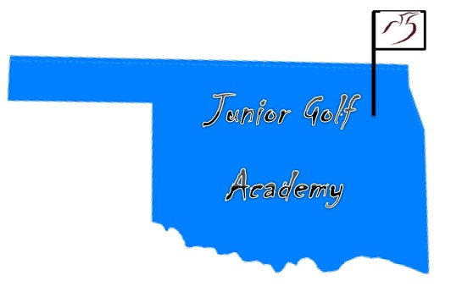
We will be outside weather permitting or inside the Player Development building working on all aspects of the game and skill development.

